Colonial Story of the Immigrant Brothers Alexander and Thomas Joyce

Brothers Arrive From Northern Ireland
To date no supporting document shows the port where Alexander and Thomas Joyce (b. 1720 & 1722 respectively) arrive in Colonial America, and similarly some limited documentation that they may have arrived with a third older brother John (see section Older Brother John Joyce). It is currently surmised that they most likely came into a more northern port such as New Castle, DE for a variety of reasons including religion, taxes, support systems, and other Scotch-Irish supporting families.
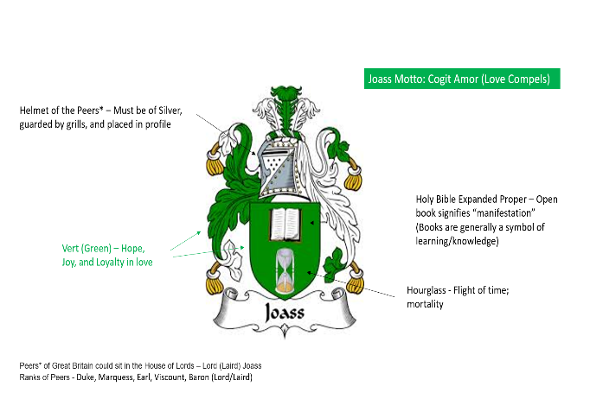
The Joyce brothers likely arrived sometime around late 1730s or early 1740s before the earliest record we have of them in Louisa Co. VA 1743, which means they were very young adults at the time. One of their primary reasons was looking for a better life, which included leaving religious persecution in Northern Ireland. We know that their Joass/Joyce ancestors share a very common and strong thread of Presbyterianism and education throughout the family story. This is best demonstrated by the Joass Coat of Arms (Figure 1) which has as one of the elements as the “Holy Bible Expanded Proper”.
Figure 1 – Laird Joass of Colleonard Coat of Arms
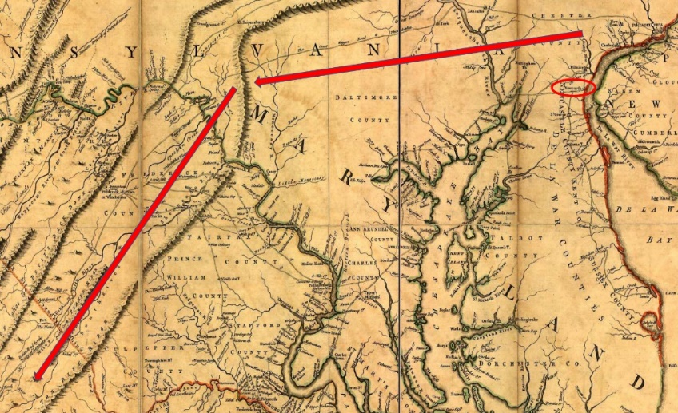
At the time of the Joyce brothers’ arrival, there was only one Presbyterian Synod in Colonial America, the Philadelphia Synod which consisted of three Presbytery (Philadelphia, New Castle, and Long Island). Many of the early Scotch-Irish arrived through these 3 main ports. Specifically, the Scotch-Irish families that eventually ended up in Lunenburg County (today’s Charlotte Co.) including the more famous Caldwells who founded Cub Creek and Buffalo Creek Settlements came through New Castle, DE, down the Shenandoah Valley to Virginia, and Louisa County (Buck Mountain Area) and eventually to Lunenburg County Virginia (see section on Lunenburg Scotch-Irish Immigration Patterns). Like most of these families, it is assumed they all made a similar migration path, as they likely were supported along the way by fellow Scotch-Irish Northern Irelanders and Presbyterian communities who had blazoned the way previously. Another reason of support for New Castle as the port of entry, is at the time immigrants were typically taxed upon entry, but these taxes were lower for New Castle (which also acted as a clearing port for Philadelphia), and were often not taken at all.
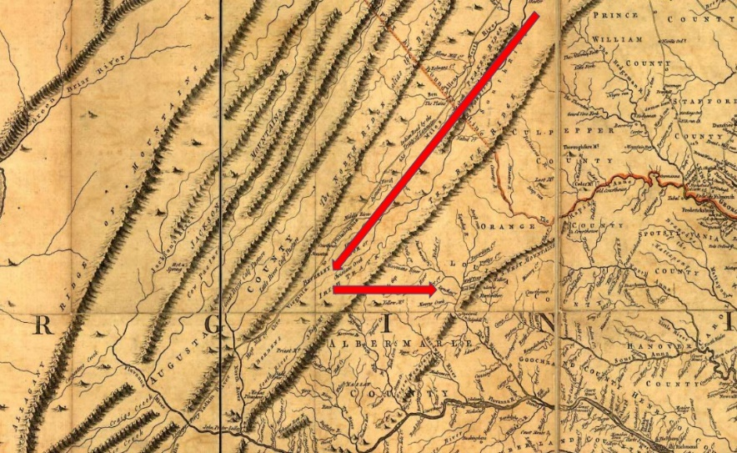
If New Castle was the port of entry, it was unclear how long they stayed in the area, and at some time the brothers likely migrated down the Shenandoah Valley and eventually across the Blue Ridge mountains. Many Irish and Scotch immigrants were forced to migrate south due restrictions posed by entrenched white landowners and frequent Indian attacks in the frontiers of Pennsylvania at the time. This migration was of such a large amount that it was noted by William Byrd “like the Goths and Vandals of Old”.
The earliest record of the Joyce brothers was a Louisa County, VA Deed dated 1743. In the deed John Joyce is a witness, on a sale between Andrew Rea and John Thomson, also witnessed by Abraham Venable a surname that shows up later in Prince Edward and Lunenburg County. As highlighted previously, like the other Scotch-Irish Presbyterian families that made their way to Lunenburg County, it was likely through a series of moves. First, down the Shenandoah Valley utilizing the Great Wagon Road to Virginia (figures above and below from Great Wagon Road – Wikipedia), where there were very large and well established Presbyterian communities like Augusta County, and across to Louisa County through Rock Fish Gap using the Three Notched Road which leads eventually on to Richmond (parallels current I-64). It is also possible/probable that they then settled in the Buck Mountain area of Louisa Co. Virginia just northwest of Charlottesville.
There is a 1747 Order listing “Thomas Joyce of Louisa County”. A record of Alexander Joyce exists as a witness in a Louisa County Deed dated August 15, 1748 (the deed involves George Clark, who becomes a neighbor of Alexander and Thomas in Lunenburg). Since he and Thomas later move to Lunenburg County, and become an elder in the Caldwell Settlement Churches (Cub Creek and Buffalo Creek Churches), it is possible they lived close to John Caldwell in Louisa County.
Buck Mountain, Louisa Co. Virginia is where John Caldwell settled prior to moving on to Cub Creek and Buffalo Creek settlements. There is an entry in Rev. John Craig’s journal of three baptisms for 18 Dec 1740 indicating they occurred "at John Caldwell's at Buck Mountain".
Rev. John Craig (1709-1774), who had studied theology under Rev. John Thomson (1690-1753) at the Chestnut Level Presbyterian Church, was then assigned by the Donegal Presbytery as an 'itinerant' (traveling) minister for those Presbyterian settlements located in the Shenandoah Valley & nearby communities. In 1740 he founded both the Tinkling Spring church in Fishersville, VA and the Augusta Stone church in Ft. Defiance, VA where he is buried in the old cemetery.
Rev. John Thomson will be discussed in more detail later, but eventually he founded Buffalo Creek Church, Prince Edward Co. Virginia.
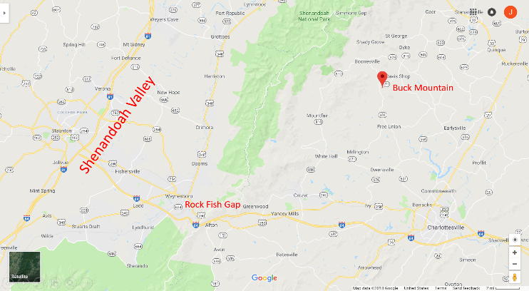
Buck Mountain area was known to be an area where tobacco was grown, and eventually made it to markets in the ports of Richmond on the James River, and Fredericksburg on the Rappahannock River via the Buck Mountain and Coursey’s Roads, which tied to the Fredericksburg Road and Three Notched Road which led to Richmond.
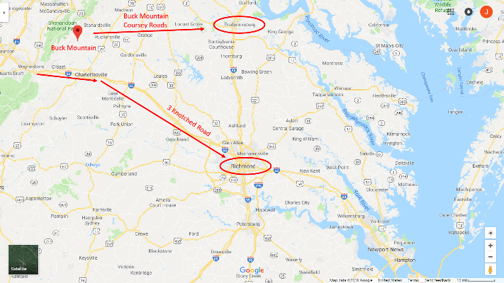
We know later that Alexander and Thomas Joyce were tobacco farmers in Lunenburg County and likely learned their trade during their stay in Louisa County.
It is also during this time that Alexander Joyce married Sarah Austin (daughter of Richard Austin III b. 1690) and had the first four of their children together Alexander (b. 1741), Thomas (b. 1743), John (b. 1743), and James (b. 1746).
It is less clear who/when/where the brother Thomas Joyce gets married as his first child Mary was either born in 1747 or 1748 (no supporting documents have been discovered by this writer at this point in time).
We now pick up the story when both brothers Alexander and Thomas Joyce purchase lands in Lunenburg County in May, 1748.

